Early Sensing of the Four Horsemen Worksheet

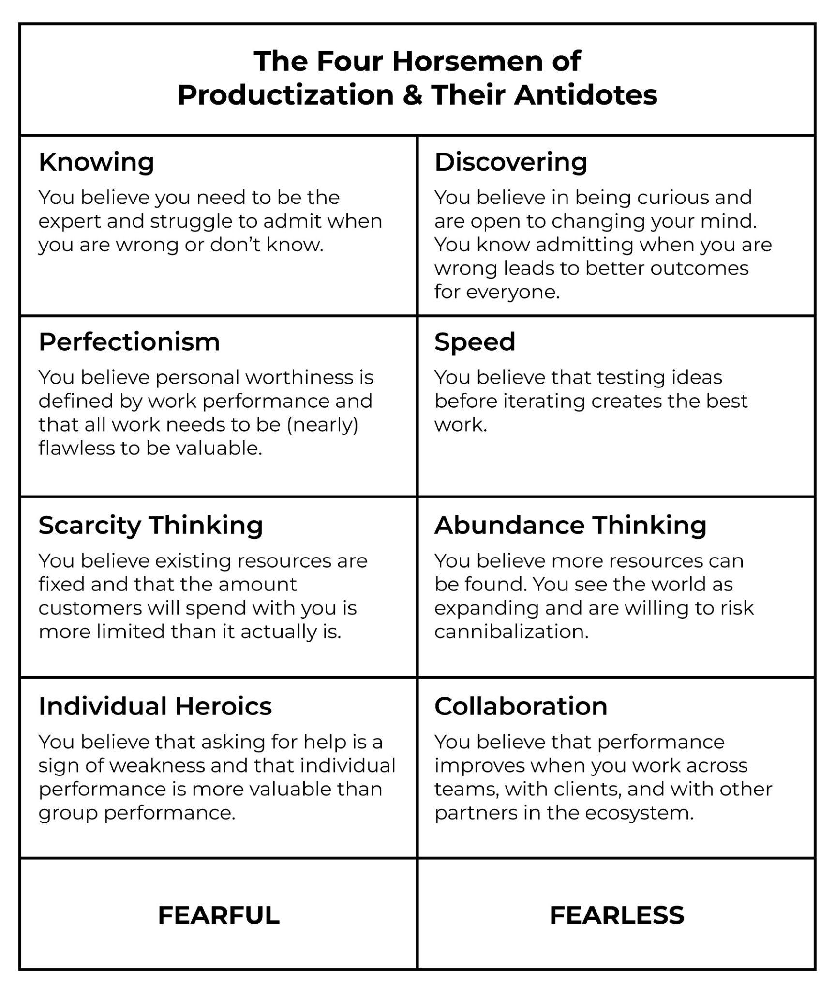

Knowing ➡️ Discovering

- How does this present in our organization today?
- Who needs to help to change ‘Knowing’ behaviors?
- How can we operate in ways to support ‘Discovering’ behaviors?
- Who would be able to identify if ‘Knowing’ behaviors are coming back?
- What incentives need to be aligned with ‘Discovering’ behaviors?
Perfectionism ➡️ Speed

- How does this present in our organization today?
- Who needs to help to change ‘Perfectionism’ behaviors?
- How can we operate in ways to support ‘Speed’ behaviors?
- Who would be able to identify if ‘Perfectionism’ behaviors are coming back?
- What incentives need to be aligned with ‘Speed’ behaviors?

Scarcity Thinking ➡️ Abundance Thinking

- How does this present in our organization today?
- Who needs to help to change ‘Scarcity Thinking’ behaviors?
- How can we operate in ways to support ‘Abundance Thinking’ behaviors?
- Who would be able to identify if ‘Scarcity Thinking’ behaviors are coming back?
- What incentives need to be aligned with ‘Abundance Thinking’ behaviors?

Individual Heroics ➡️ Collaboration

- How does this present in our organization today?
- Who needs to help to change ‘Individual Heroics’ behaviors?
- How can we operate in ways to support ‘Collaboration’ behaviors?
- Who would be able to identify if ‘Individual Heroics’ behaviors are coming back?
- What incentives need to be aligned with ‘Collaboration’ behaviors?

